Name:

Comprehension Question Packet

A Christmas Carol

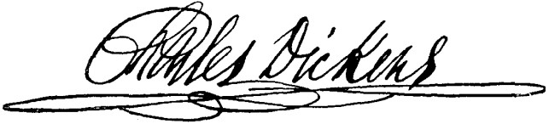

(Charles Dickens)
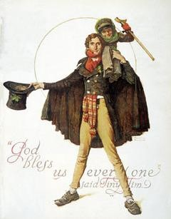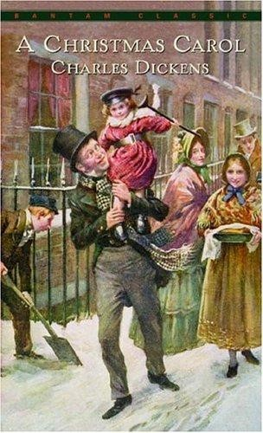
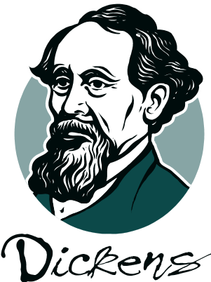
A Christmas Carol Comprehension

Questions Stave One

Answer all questions using COMPLETE SENTENCES!!!!

PROLOGUE & CHAPTER 1

- Describe the relationship between Scrooge and Marley.

___________________________________________________________________________________

___________________________________________________________________________________

___________________________________________________________________________________

___________________________________________________________________________________

- What is Scrooge’s job? If he were alive today, what type of job do you think he would have? Why?

___________________________________________________________________________________

___________________________________________________________________________________

___________________________________________________________________________________

___________________________________________________________________________________

- On p. 9 it says that it has been 7 years since Marley had died but the sign at the office still read “Scrooge and Marley”. Why do you think that Scrooge didn’t bother to change the sign?

___________________________________________________________________________________

___________________________________________________________________________________

- On p. 10 it states that Scrooge loaned people money but they had to pay back an exorbitant fee. What does the word exorbitant mean?
___________________________________________________________________________________

___________________________________________________________________________________

- Why do you think that Scrooge refused to allow more than one piece of coal to be on the burner at a time?
___________________________________________________________________________________

___________________________________________________________________________________

- What do the “portly gentlemen” want?

___________________________________________________________________________________

___________________________________________________________________________________

___________________________________________________________________________________

- Describe Scrooge’s attitude toward the poor and the unfortunate? Provide a quote of Scrooge’s that sums up his attitude.

___________________________________________________________________________________

___________________________________________________________________________________

___________________________________________________________________________________

___________________________________________________________________________________

___________________________________________________________________________________

___________________________________________________________________________________

- On p. 20, Scrooge smiles when the man from the charity mentions that many people would rather die than go to prison or union workhouses. Why do you think Scrooges smiled at the mention of this?
___________________________________________________________________________________

___________________________________________________________________________________

- How does Scrooge treat his clerk? How does he respond to his clerk’s request for Christmas day off?

___________________________________________________________________________________

___________________________________________________________________________________

___________________________________________________________________________________

___________________________________________________________________________________

10. How would you characterize Cratchit based on the fact that he chose to go sledding with the children down the snowy hill?

___________________________________________________________________________________

___________________________________________________________________________________

11. Why do you think Scrooge’s house has gone from beautiful to rundown and filthy?

___________________________________________________________________________________

___________________________________________________________________________________

12. What strange incident happens to Scrooge as he reaches his house? What does it indicate?

___________________________________________________________________________________

___________________________________________________________________________________

___________________________________________________________________________________

13. Foreshadowing is the process of the author hinting at something that will be happening next in the story. What do the shadows transforming themselves into a terrifying image foreshadow? (p. 26)

___________________________________________________________________________________

___________________________________________________________________________________

___________________________________________________________________________________
14. On. p. 27 it says that Scrooge at a plate of gruel. Why do you think that Scrooge constantly eats low quality food?

___________________________________________________________________________________

___________________________________________________________________________________

___________________________________________________________________________________

15. Why is it ironic that there are images of people from the bible on the tiles of Scrooge’s floor?

___________________________________________________________________________________

___________________________________________________________________________________

___________________________________________________________________________________

CHAPTER 2

- Describe Marley’s ghost – provide both a physical and emotional description.
___________________________________________________________________________________

___________________________________________________________________________________

___________________________________________________________________________________

- On p. 33, Marley’s Ghost has cashboxes, ledgers, and other things from the business attached to him with chains. What do the things attached to the chains symbolize?

___________________________________________________________________________________

___________________________________________________________________________________

___________________________________________________________________________________

- What does Scrooge think has caused this ghost to appear? Why does Scrooge doubt that Marley’s ghost is actually in front of him?

___________________________________________________________________________________

___________________________________________________________________________________

___________________________________________________________________________________

- What does Marley tell Scrooge he’s been doing in the seven years since his death?

___________________________________________________________________________________

___________________________________________________________________________________

___________________________________________________________________________________

- Based upon the interaction Scrooge is having with Marley’s ghost and what we know about Marley, what type of relationship do you think they had when Marley was alive?
___________________________________________________________________________________

___________________________________________________________________________________

- What do Marley’s chains represent?

___________________________________________________________________________________

___________________________________________________________________________________

___________________________________________________________________________________

- What warning does Marley give to Scrooge?

___________________________________________________________________________________

___________________________________________________________________________________

___________________________________________________________________________________

- What emotions has Scrooge felt during Marley’s visit? What is his mood like after Marley leaves?

___________________________________________________________________________________

___________________________________________________________________________________

___________________________________________________________________________________

Stave two
Answer all questions in COMPLETE SENTENCES!!!!!

CHAPTER 3

- Why is it ironic that Scrooge chose to pray when he was nervous/frightened?
___________________________________________________________________________________

___________________________________________________________________________________

- Describe the appearance of the first spirit.

___________________________________________________________________________________

___________________________________________________________________________________

___________________________________________________________________________________

- What was the strangest thing about the way the spirit looked?

___________________________________________________________________________________

___________________________________________________________________________________

- What is the first spirit called? What does this spirit symbolize?

___________________________________________________________________________________

___________________________________________________________________________________

___________________________________________________________________________________

- How does Scrooge initially react to the Spirit? What is his attitude?

___________________________________________________________________________________

___________________________________________________________________________________

___________________________________________________________________________________

- On p. 49 Scrooge begins to cry but is quickly embarrassed. Why do you think he was embarrassed to cry? Why do you think he began to cry?

___________________________________________________________________________________

___________________________________________________________________________________

___________________________________________________________________________________

- What part of his past does the spirit show to Scrooge first?

___________________________________________________________________________________

___________________________________________________________________________________

___________________________________________________________________________________

- What do you learn about Scrooge when his sister, Fan, visits him at school?

___________________________________________________________________________________

___________________________________________________________________________________

___________________________________________________________________________________

- What kind of people are the Fezziwigs? Describe them in all aspects.

___________________________________________________________________________________

___________________________________________________________________________________

___________________________________________________________________________________

- Contrast Scrooge’s old Christmas celebrations with those of the Fezziwigs.

___________________________________________________________________________________

___________________________________________________________________________________

___________________________________________________________________________________

- Why does Belle end her relationship with Scrooge? What does she say to him?

___________________________________________________________________________________

___________________________________________________________________________________

___________________________________________________________________________________

- What does Scrooge regret as he watches each scene from the past unfold?

___________________________________________________________________________________

___________________________________________________________________________________

___________________________________________________________________________________

- How does Scrooge try to “extinguish the light”? Does he succeed?

___________________________________________________________________________________

___________________________________________________________________________________

___________________________________________________________________________________

- What does the light symbolize?

___________________________________________________________________________________

___________________________________________________________________________________

___________________________________________________________________________________

- How has Scrooge changed after the visit by the Ghost of Christmas Past?

___________________________________________________________________________________

___________________________________________________________________________________

___________________________________________________________________________________

Stave 3
CHAPTER 4

- What first alerts Scrooge to the presence of the second spirit? How does he respond?

___________________________________________________________________________________

___________________________________________________________________________________

___________________________________________________________________________________

- When the second spirit invites Scrooge into the room, what does Scrooge find there?

___________________________________________________________________________________

___________________________________________________________________________________

___________________________________________________________________________________

- Describe the second spirit physically.

___________________________________________________________________________________

___________________________________________________________________________________

___________________________________________________________________________________

- Describe the personality of the second spirit.

___________________________________________________________________________________

___________________________________________________________________________________

___________________________________________________________________________________

- What does the spirit mean when it says it has more than eighteen hundred brothers?
___________________________________________________________________________________

___________________________________________________________________________________

___________________________________________________________________________________

- Where does the Ghost of Christmas Present take Scrooge on the first part of their journey? What do they see?

___________________________________________________________________________________

___________________________________________________________________________________

___________________________________________________________________________________

- What do you think is going through Scrooge’s mind as he looks down at the Cratchit household? Take the first person perspective and describe what Scrooge is thinking.
___________________________________________________________________________________

___________________________________________________________________________________

___________________________________________________________________________________

- Describe the Cratchits’ reaction to their Christmas feast. What does their celebration show Scrooge?

___________________________________________________________________________________

___________________________________________________________________________________

___________________________________________________________________________________

- What does the spirit predict will happen to Tiny Tim? How does Scrooge respond?

___________________________________________________________________________________

___________________________________________________________________________________

- What toast does Bob Cratchit make to the surprise of Scrooge and the regret of Mrs. Cratchit? Why does Cratchit make this toast? Why is it surprising?

___________________________________________________________________________________

___________________________________________________________________________________

___________________________________________________________________________________

- Why does Fred continue to see his uncle?

___________________________________________________________________________________

___________________________________________________________________________________

___________________________________________________________________________________

- How does the spirit change as the night progresses? Why does the spirit change?

___________________________________________________________________________________

___________________________________________________________________________________

___________________________________________________________________________________

- Describe the two children that emerge from the second spirit’s robes.

___________________________________________________________________________________

___________________________________________________________________________________

___________________________________________________________________________________

- What do they symbolize? How are they “man’s children?”

___________________________________________________________________________________

___________________________________________________________________________________

___________________________________________________________________________________

- How does Scrooge change as a result of his visit with the Ghost of Christmas Present?

___________________________________________________________________________________

___________________________________________________________________________________

___________________________________________________________________________________

Stave 4
CHAPTER 5

- Describe the Ghost of Christmas Yet to Come. In what ways is this spirit very different from those that came before? What does this spirit lack that the others had? Why do you think it lacks this quality?

___________________________________________________________________________________

___________________________________________________________________________________

___________________________________________________________________________________

___________________________________________________________________________________

___________________________________________________________________________________

- What is Scrooge’s reaction to this spirit? Is his reaction the same or different from the other spirits?

___________________________________________________________________________________

___________________________________________________________________________________

___________________________________________________________________________________

___________________________________________________________________________________

___________________________________________________________________________________

- What does the spirit show Scrooge first? What are the men talking about?

___________________________________________________________________________________

___________________________________________________________________________________

___________________________________________________________________________________

- What does Scrooge keep looking for during this part of the journey?

___________________________________________________________________________________

___________________________________________________________________________________
- Who are the people at Old Joe’s Scavenger Shop and what are they doing?

___________________________________________________________________________________

___________________________________________________________________________________

___________________________________________________________________________________

- Does anyone care about the dead man in the bedroom? Why?

___________________________________________________________________________________

___________________________________________________________________________________

___________________________________________________________________________________

- Scrooge asks the spirit to show him tenderness connected to a death. What does the spirit show him?

___________________________________________________________________________________

___________________________________________________________________________________

___________________________________________________________________________________

- Scrooge’s last request is to know what shall become of him in the days ahead. What does the spirit show him? How does Scrooge respond to what he is shown?

___________________________________________________________________________________

___________________________________________________________________________________

___________________________________________________________________________________

- What is the lesson Scrooge learns in this stave that he had not learned before?

___________________________________________________________________________________

___________________________________________________________________________________

___________________________________________________________________________________

- Why is this stave necessary when Scrooge has already changed so much?

___________________________________________________________________________________

___________________________________________________________________________________

___________________________________________________________________________________

- What does Scrooge promise the spirit?

___________________________________________________________________________________

___________________________________________________________________________________

___________________________________________________________________________________

- Why do you think the author chose to have the Ghost of Christmas Future not speak during the entire scene?
___________________________________________________________________________________

___________________________________________________________________________________

___________________________________________________________________________________

- What do you think has been the most influential vision that Scrooge has seen in the book thus far?

___________________________________________________________________________________

___________________________________________________________________________________

___________________________________________________________________________________

Stave 5
CHAPTER 6 & EPILOGUE

- When Scrooge finds himself in his bedchamber, he lets out a gleeful cheer. At the beginning of the book, what do you think Scrooge’s reaction would have been?
___________________________________________________________________________________

___________________________________________________________________________________

___________________________________________________________________________________

- How does Scrooge feel when he realizes the visits are over?

___________________________________________________________________________________

___________________________________________________________________________________

___________________________________________________________________________________

- What actions does Scrooge take to make amends for the past?

___________________________________________________________________________________

___________________________________________________________________________________

___________________________________________________________________________________

- How does Scrooge reconcile with Fred, his nephew?

___________________________________________________________________________________

___________________________________________________________________________________

___________________________________________________________________________________

- Describe Scrooge’s interaction with Bob Cratchit at his office. What is Bob’s response?

___________________________________________________________________________________

___________________________________________________________________________________

___________________________________________________________________________________

- What lesson has Scrooge learned?

___________________________________________________________________________________

___________________________________________________________________________________

___________________________________________________________________________________

- What type of a person is Scrooge at the end of the story?

___________________________________________________________________________________

___________________________________________________________________________________

___________________________________________________________________________________

- Re-write the ending of Scrooge’s life if the spirits had never come to visit him. How would it have been similar? How would it have been different?
___________________________________________________________________________________

___________________________________________________________________________________

___________________________________________________________________________________

___________________________________________________________________________________

___________________________________________________________________________________

___________________________________________________________________________________

