HOW TO – DOWNLOADING AND USING MICROSOFT TEAMS

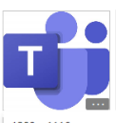
- Google Microsoft Teams App. It looks like this:

- Download the Microsoft Teams app to your device.

- Once downloaded click sign in using email, do not try to ‘create an account’. Enter your school email (which has been attached to this letter) and your password which is Happy123

- You will be asked to create a new password. Your current password is Happy123, then enter a new password and confirm it, do not use words such as Password1 as this is not secure enough and will not be accepted. Use a combination of upper and lower case letters and numbers/symbols such as $ % £.

- To join a meeting (lesson) click the Calendar and then join a scheduled meeting
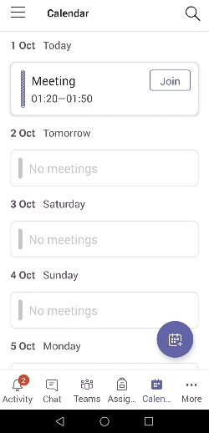

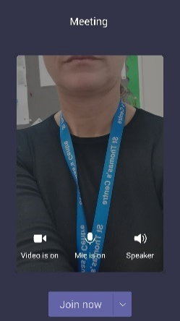

- During a lesson switch your camera on and micprohone off.

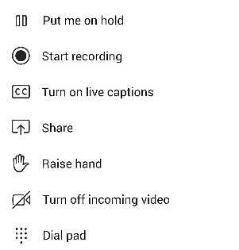
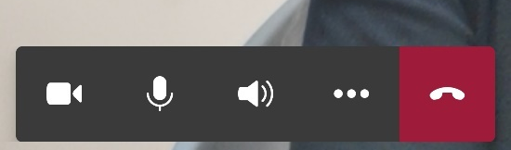
- By clicking the 3 dots you can Raise your hand to ask a question during the lesson.
Ends the call

